DBMS Lab Questions and Answers

1. Insert a new employee into the Employees table.
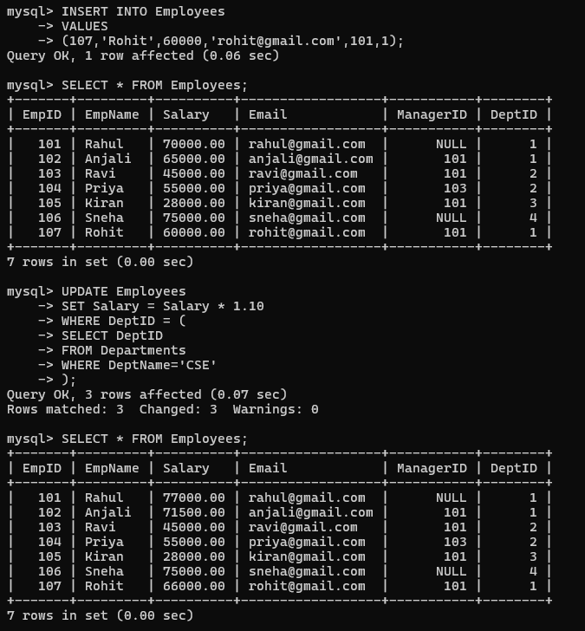

2. Update the salary of employees working in the CSE department by 10%.


3. Delete employees whose salary is below 30,000.
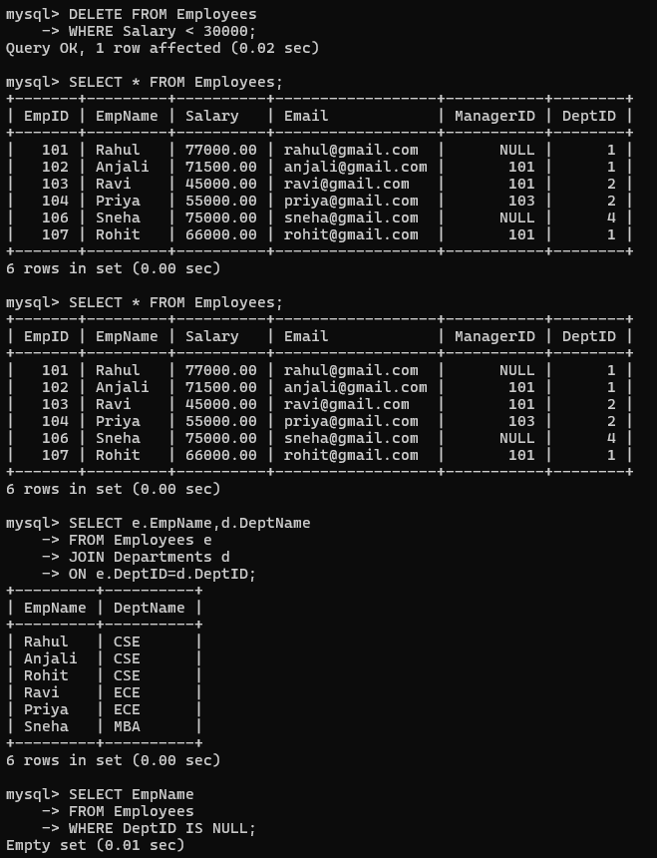

4. Display all employee details.


5. Display employee names along with department names.


6. Display employees who do not belong to any department.


7. Display all departments even if they have no employees.
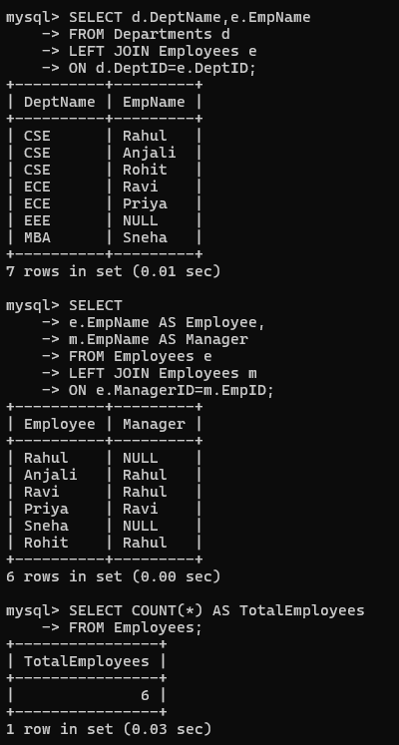

8. Display employee and manager names using SELF JOIN.


9. Find the total number of employees.


10. Find department-wise average salary.
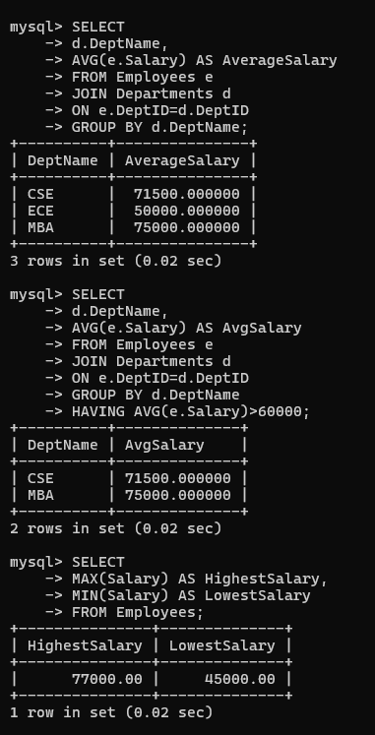

11. Display departments where average salary exceeds 60,000.


12. Display the highest and lowest salary.


13. Display employees earning more than the average salary.
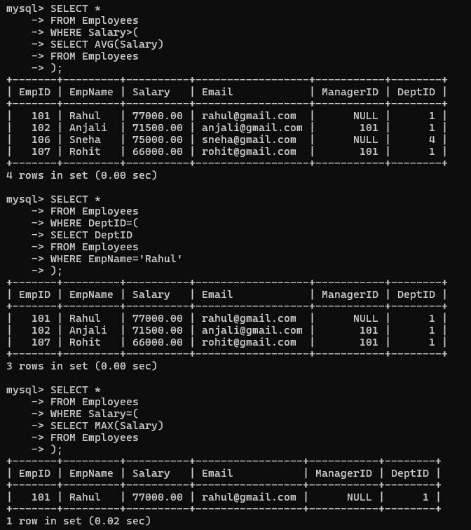

14. Find employees working in the same department as Rahul.


15. Display the employee receiving the highest salary.


16. Display departments having more than five employees.
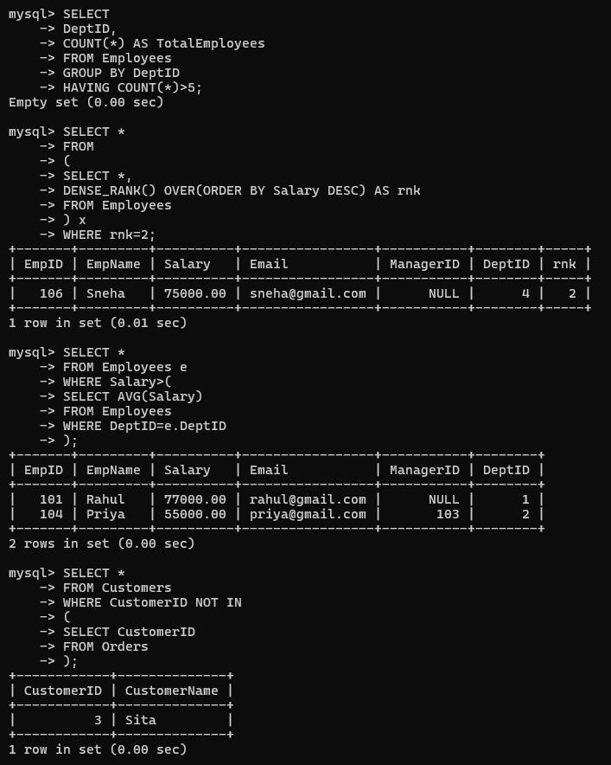

17. Find the second-highest salary using a window function.


18. Display employees earning above their department's average salary.


19. Find customers who have never placed an order.


20. Display the top-selling product.
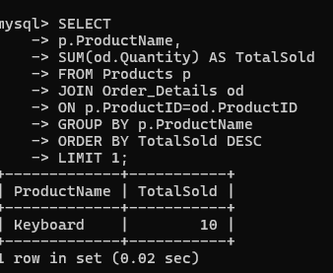

21. Find departments with the maximum number of employees.
Answer screenshot not provided.

22. Display monthly sales using window functions.
Answer screenshot not provided.

23. Rank customers based on total purchase amount.
Answer screenshot not provided.

24. Display employees whose salary is greater than their manager's salary.
Answer screenshot not provided.

25. Find duplicate email addresses using GROUP BY and HAVING.
Answer screenshot not provided.

Additional Answers (Questions 21-25)
